Grand slam is playing over four different locations in the recent times, named Australian open, French open, US open and Wimbledon open. Who won how many titles and who played final multiple times have been showed using the graphs.

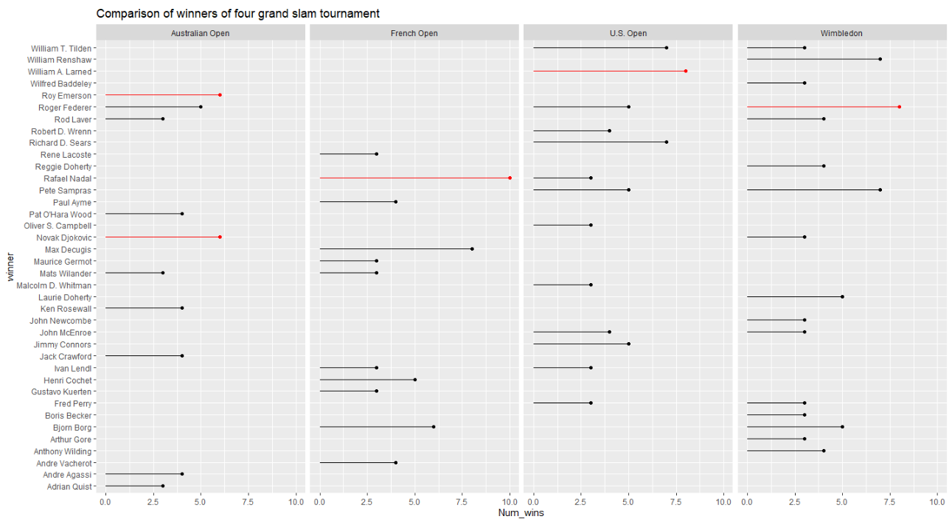

Above is the first visualization made to compare the performance of winners of four grand slam tournaments. All the four grand slam tournament separated using the facet_grid() function. The comparison of frequencies has to be made so used lollipop chart. (Wong J., 2020). Due to too much cluttering appeared only those who won any titles more than two times have been shown. Color has been used to show the greatest number of wins in all the four tournaments individually where red color represents the winner who won the particular grand slam the most. Appropriate graph title and axis labels has been shown to represent purpose of the graph and what the axis represents.

Figure 5

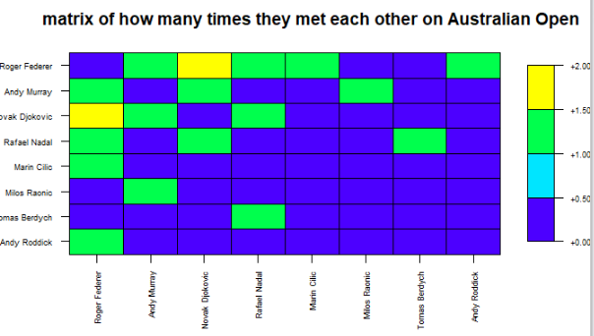

Above visualization has been done to highlight how many times the winners and runner_ups met each other in the finals of Australian Open in most recent 40 tournaments. The matrix has been generated first to calculate how many times they have met each other while setting diagonal values to 0 as no player can met himself in the final. Heat map is used to highlight meeting opponent in the final where colours has been used to define frequencies of their meeting. Here both the axis represents players name. Appropriate title has been shown to represent the purpose of the graph and removed the axis lables to better see the names in the labels. Based on the heat map it can be seen that only Novak Djokovic has met Rafael Nadal and Andy Murray both for the most times. Same way four graphs have been generated.